1.
Capture and analyze ARP packets using Wireshark. Inspect the ARP request and reply frames when your device attempts to find the router's MAC address.
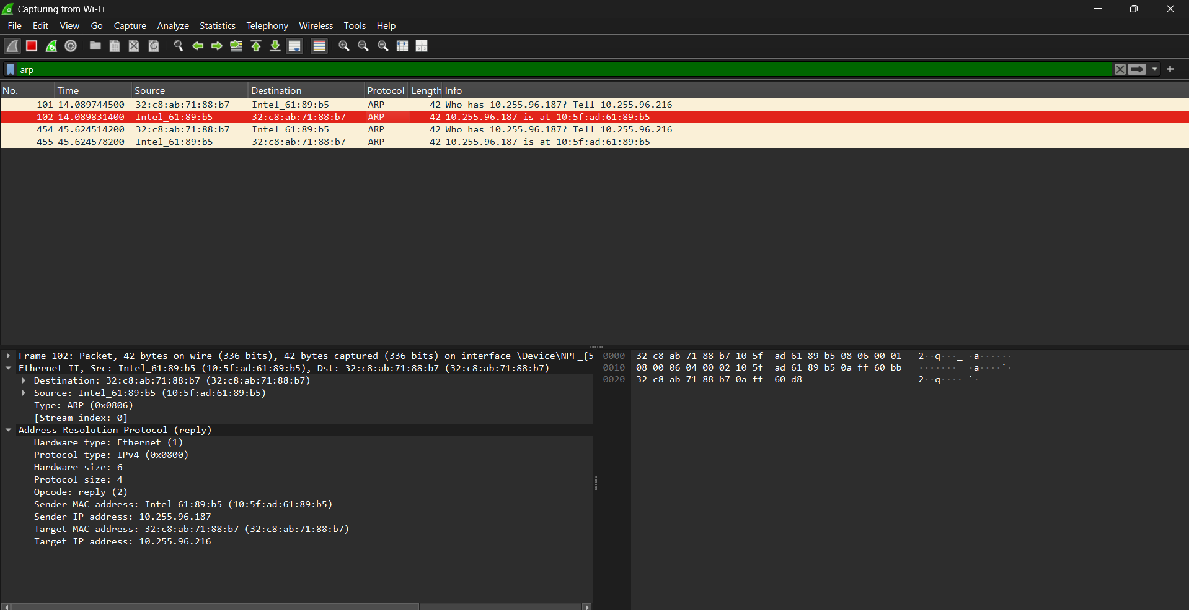

2. Manually configure static routes on a router to direct packets to different subnets.Use the ip route command and verify connectivity using ping and traceroute.
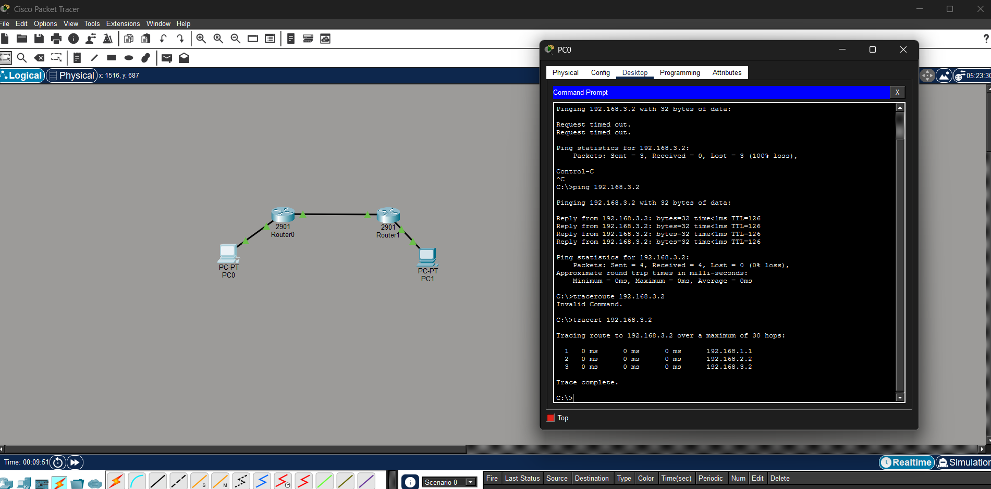
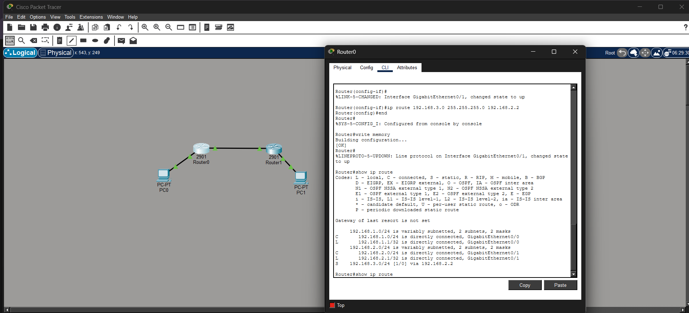
Configure Router Interfaces
✅ On R1
enable
configure terminal
interface g0/0
ip address 192.168.1.1 255.255.255.0
no shutdown
interface g0/1
ip address 10.0.0.1 255.255.255.0
no shutdown

✅ On R2
enable
configure terminal
interface g0/0
ip address 10.0.0.2 255.255.255.0
no shutdown
interface g0/1
ip address 192.168.2.1 255.255.255.0
no shutdown

🔹 4. Configure Static Routes
✅ On R1 (to reach Network 3)
ip route 192.168.2.0 255.255.255.0 10.0.0.2

✅ On R2 (to reach Network 1)
ip route 192.168.1.0 255.255.255.0 10.0.0.1

🔹 5. Configure PCs
PC1:
IP: 192.168.1.2
Gateway: 192.168.1.1
PC2:
IP: 192.168.2.2
Gateway: 192.168.2.1

3. Given a network address of 10.0.0.0/24, divide it into 4 equal subnets.
Calculate the new subnet mask.
Determine the valid host range for each subnet.
Step 1: Determine the number of bits to borrow
- Original subnet mask: /24 → 255.255.255.0
- We need 4 subnets.
Formula:
$$2^{n}=\text{number of subnets} \\ 2^{n}=4 ⟹ n=2$$
✅ Borrow 2 bits from the host portion.

Step 2: Calculate new subnet mask
- Original mask: 255.255.255.0 → /24
- Borrow 2 bits → new mask = /26
- Subnet mask in decimal:
$$/26=255.255.255.192$$Explanation:
- Last octet: 8 bits → borrow 2 bits
- Binary: 11000000 → 128 + 64 = 192

Step 3: Determine the number of hosts per subnet
Formula:
$$\text{Hosts per subnet}=2^{\text{host bits}}-2$$Host bits = 8 – 2 = 6
- Hosts per subnet = 2^6 – 2 = 64 – 2 = 62 hosts

Step 4: Subnet ranges
- Original network: 10.0.0.0/24 → 256 addresses
- Divide into 4 subnets → each subnet has 64 addresses (including network & broadcast)
Subnet | Network Address | First Host | Last Host | Broadcast Address
1 | 10.0.0.0 | 10.0.0.1 | 10.0.0.62 | 10.0.0.63
2 | 10.0.0.64 | 10.0.0.65 | 10.0.0.126 | 10.0.0.127
3 | 10.0.0.128 | 10.0.0.129 | 10.0.0.190 | 10.0.0.191
4 | 10.0.0.192 | 10.0.0.193 | 10.0.0.254 | 10.0.0.255

4. You are given three IP addresses: 192.168.10.5, 172.20.15.1, and 8.8.8.8. Identify the class of each IP address. Determine if it is private or public. Explain how NAT would handle a private IP when accessing the internet.
(a) 192.168.10.5
- First octet: 192 → falls in 192–223 → Class C
- Default subnet mask: 255.255.255.0 (/24)
- Private/Public: 192.168.x.x is private (RFC 1918)
- Use case: Used in LANs; not routable on the internet

(b) 172.20.15.1
- First octet: 172 → falls in 128–191 → Class B
- Default subnet mask: 255.255.0.0 (/16)
- Private/Public: 172.16.0.0 – 172.31.255.255 is private
- Use case: LAN or corporate networks; not public

(c) 8.8.8.8
- First octet: 8 → falls in 1–126 → Class A
- Default subnet mask: 255.0.0.0 (/8)
- Private/Public: Public (owned by Google)
- Use case: Internet-routable, can be accessed globally

2. Summary Table
IP Address | Class | Default Subnet Mask | Private/Public | Notes
192.168.10.5 | C | 255.255.255.0 | Private | LAN usage
172.20.15.1 | B | 255.255.0.0 | Private | Corporate LAN
8.8.8.8 | A | 255.0.0.0 | Public | Google DNS server

3. How NAT Handles a Private IP for Internet Access
- Scenario: A PC with a private IP (e.g., 192.168.10.5) wants to access a website on the internet.
- Problem: Private IPs are not routable on the internet. Routers will drop packets with private source IPs.
- Solution: NAT (Network Address Translation) on the router replaces the private source IP with the router’s public IP.
Step-by-step NAT process:
- PC sends packet to internet destination (e.g., 8.8.8.8)
- Router intercepts packet, performs Source NAT (SNAT):
  - Changes source IP from 192.168.10.5 → router’s public IP (e.g., 203.0.113.10)
  - Records translation in NAT table
- Internet host (8.8.8.8) replies → packet goes to router’s public IP
- Router looks up NAT table → translates destination back to 192.168.10.5
- Packet delivered to original PC
NAT allows multiple private IPs in a LAN to share a single public IP for internet access.

4. Visual Summary
PC (192.168.10.5) --> NAT Router --> Internet (8.8.8.8)
[Private IP] [Public IP] [Public Internet IP]
- Outgoing: 192.168.10.5 → 203.0.113.10
- Incoming: 203.0.113.10 → 192.168.10.5

  - In Cisco Packet Tracer, configure NAT on a router to allow internal devices (192.168.1.x) to access the internet. Test connectivity by pinging an external public IP. Analyze the source IP before and after NAT translation.
